(day-13 Assignment)

1.Create an arraylist of user-defined data type Book. it should have:-

i)Name of the Book

ii)Author of the book

iii)year of publication of the book

iV)number of copies sold.

sort the array list based on the year of publication.

package SBA_2;

import java.util.*;

class Book implements Comparable{

int sold;

Integer year;

String name,author;

public Book( String name, String author, int year,int sold) {

this.name = name;

this.author = author;

this.year = year;

this.sold=sold;

}

public int getYear()

{

return this.year;

}

@Override

public int compareTo(Object o) {

Book b1=(Book) o;

return (this.year.compareTo(b1.getYear()));

}

}

public class Q1 {

public static void main(String[] args) {

//Creating list of Books

List<Book> list=new ArrayList<Book>();

//Creating Books

Book b1=new Book("Mein Kampf","Adolf Hitler",1925,100000);

Book b2=new Book("Geetanjali","Rabindra Nath Tagore",1910,6000000);

Book b3=new Book("Das Kapital","Karl Marx",1867,500000000);

//Adding Books to list

list.add(b1);

list.add(b2);

list.add(b3);

//Traversing list

Collections.*sort*(list,Collections.*reverseOrder*());

for(Book b:list){

System.*out*.println(b.name+", "+b.author+", "+b.year+", "+b.sold);

}

}

}

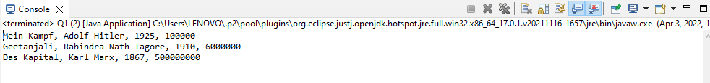

(day-14 assignment)

2.Write a program to create, write and read from a file.

package SBA_2;

import java.io.File;

import java.io.FileNotFoundException;

import java.io.FileWriter;

import java.io.IOException;

import java.util.Scanner;

public class Q2 {

public static void main(String[] args) {

try

{

FileWriter f1=new FileWriter("D:NewFile.txt");

Scanner sc=new Scanner(System.in);

System.out.println("Write data to the file");

String s=sc.nextLine();

f1.write(s);

System.out.println("Data written successfully");

f1.close();

sc.close();

}

catch(IOException e)

{

System.out.println("an unexpected error has occured");

System.out.println(e);

}

try

{

File f2=new File("D:NewFile.txt");

Scanner sc1=new Scanner(f2);

while(sc1.hasNextLine())

{

String fileData=sc1.nextLine();

System.out.print("Reading data from the file..: ");

System.out.println(fileData);

}

sc1.close();

}

catch(FileNotFoundException e)

{

System.out.println("There is some unexpected Problem");

System.out.println(e);

}

}

}

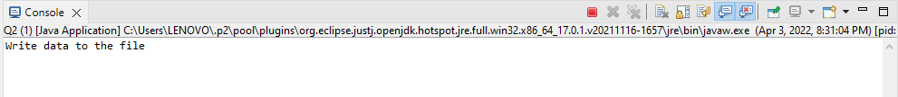

3.Write a program to get the information about the file.

package SBA_2;

import java.io.File;

import java.io.FileWriter;

import java.io.IOException;

public class Q3 {

public static void main(String[] args) throws IOException {

File f1=new File("D:FileCreateExample.txt");

FileWriter obj1=new FileWriter("D:FileCreateExample.txt");

obj1.write("Hello World..This is a Java File Program");

obj1.close();

if(f1.exists())

{

System.out.println("The file name is: "+f1.getName());

System.out.println("Is the file Writeable: "+f1.canWrite());

System.out.println("The absolute Path of the file is: "+f1.getAbsolutePath());

System.out.println("Is the file Readable: "+f1.canRead());

System.out.println("The size of the file in bytes: "+f1.length());

System.out.println("Hidden: " + f1.isHidden());//Returns true if the specified Path locates a file that is considered hidden by the file system.

System.out.println("lastModifiedTime: " + f1.lastModified());//Returns the specified file's last modified time.

System.out.println("isDirectory: " + f1.isDirectory());//Returns true if the specified Path locates a file that is a directory.

}

else

{

System.out.println("the file does not exist");

}

}

}

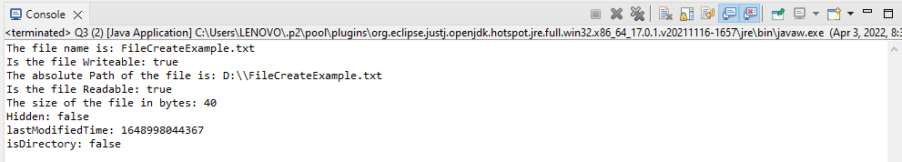

4.Write a program Implement the filereader until the file ending character is “-1” and print all the data of the file.

//4.Write a program Implement the filereader until the file ending character is “-1” and print all the data of the file.

package SBA_2;

import java.io.FileReader;

import java.io.FileWriter;

import java.io.IOException;

public class Q4 {

public static void main(String[] args) {

try

{

FileWriter obj1=new FileWriter("D:Q3_NewFile.txt");

obj1.write("Program to Implement the filereader until the file ending character is “-1” and print all the data of the file.");

obj1.close();

}

catch(IOException e)

{

System.out.println("Some unexpected error has occured");

System.out.println(e);

}

try

{

FileReader textFileReader = new FileReader("D:Q3_NewFile.txt");

int i;

while((i=textFileReader.read())!=-1)

System.out.print((char)i);

textFileReader.close();

}

catch(IOException e)

{

System.out.println("Some unexpected error has occured");

System.out.println(e);

}

}

}

